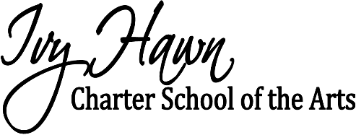 Cafeteria Volunteer Rules

Sanitary Procedures
- All volunteers must wash their hands in the kitchen hand sink before they start their shift.
- If you use the rest room at any point in time while volunteering in the cafeteria, you must rewash your hands in the kitchen hand sink before returning to help.
- Volunteers are only permitted in kitchen when requested by staff or to wash hands.
  - Your hands must be washed in hand sink.
  - Gloves and hair nets must be worn.
Volunteer Job Duties
- One parent will be asked to assist with helping students w/ their milk and juice choice at the milk box. (Volunteer needs to wash hands in kitchen hand sink and wear gloves)
- Assist students with condiments, utensils, and any items that they may need to have opened.
- Circulate throughout the cafeteria to assist students who raise their hands for help.
- Encourage students to continue to eat while they socialize.
- Volunteers may not give permission for students to use the restroom. Only Ivy Hawn Staff.
- Circulate throughout the cafeteria with trash can for students to throw away their trash about 15 mins into lunch.
- Remind children to pick up any trash that may fall on the floor.
- Assist with changing out trash bags and throwing trash in dumpster.
- Assist with cleaning up spills.
-Wipe down tables after each lunch.
We appreciate all the time and help that is given from all our volunteers. If you wish to continue to help in the cafeteria, please abide by the guidelines outlined above.

Thank you

